**IBM ASSIGNMENT-3**

|  |  |
| --- | --- |
| Assignment Date | 10 October 2022 |
| Student Name | GIFTY SHARON K |
| Student Roll Number | 953619104012 |
| Maximum Marks | 2 Marks |

**Question-1 :**

What is 7 to the power of 4?

**Solution :**

print(7**4)

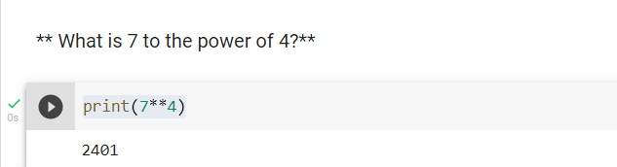

**Expected Output :**

2401

**Question-2** :

Split this string: s = "Hi there Sam!" into a list.

**Solution :**

s="Hi there Sam!"

x=s.split()

print(x)

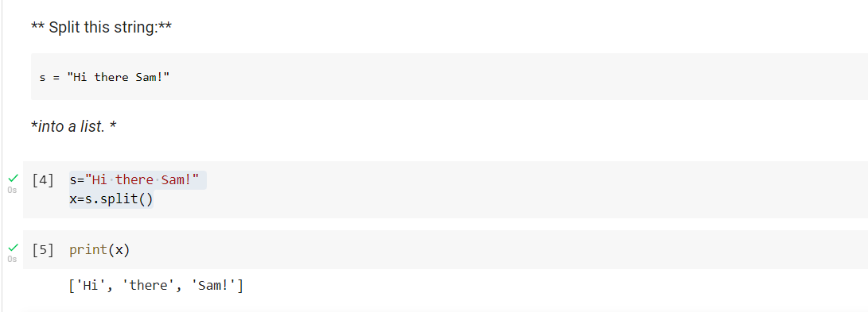

**Expected Output :**

['Hi', 'there', 'Sam!']

**Question-3 :**

Given the variables:

planet = "Earth"

diameter = 12742

Use .format() to print the following string:

The diameter of Earth is 12742 kilometers.

**Solution :**

str="The diameter of {planet} is {diameter} kilometers".format(planet= "Earth",diameter=12742)

print(str)

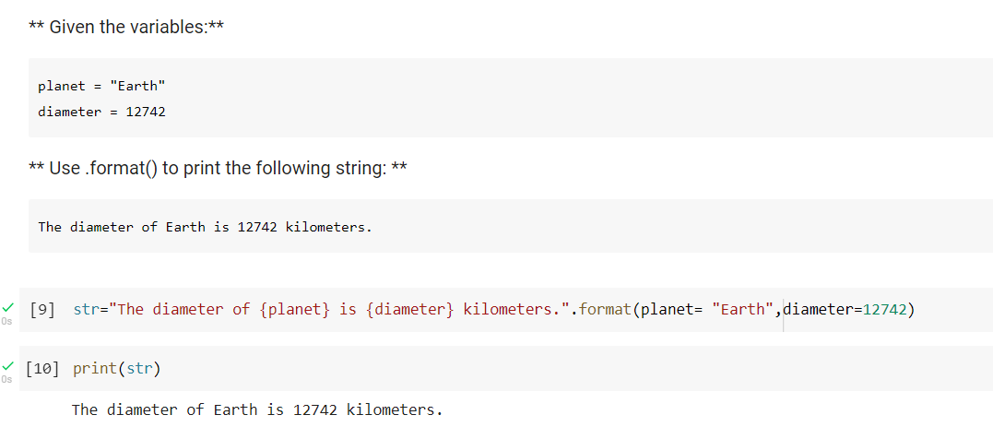

**Expected Output :**

The diameter of Earth is 12742 kilometers.

**Question-4 :**

Given this nested list, use indexing to grab the word "hello"

lst = [1,2,[3,4],[5,[100,200,['hello']],23,11],1,7]

**Solution :**

print(lst[3][1][2][0])

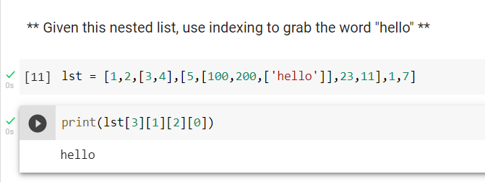

**Expected Output :**

'hello'

**Question-5:**

Given this nest dictionary grab the word "hello". Be prepared, this will be annoying/tricky

d = {'k1':[1,2,3,{'tricky':['oh','man','inception',{'target':[1,2,3,'hello']}]}]}

**Solution :**

print(d['k1'][3]['tricky'][3]['target'][3])

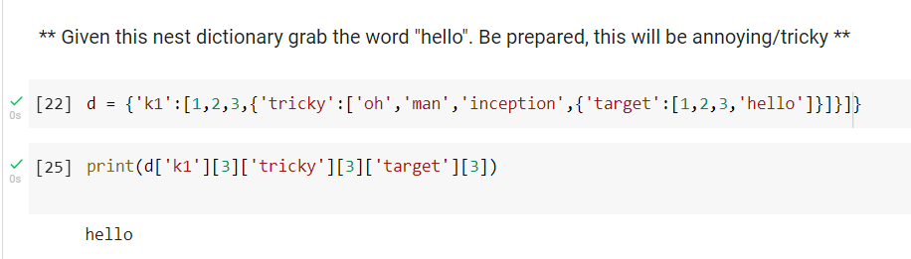

**Expected Output :**

'hello'

**Question-6 :**

What is the main difference between a tuple and a list?

**Solution :**

tuples are immutable whereas lists which are mutable

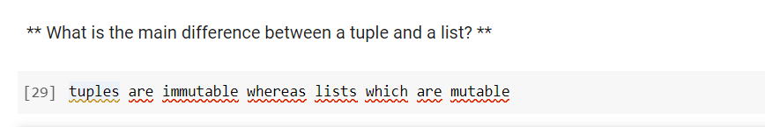

**Question-7 :**

Create a function that grabs the email website domain from a string in the form:

user@domain.com

So for example, passing "user@domain.com" would return: domain.com

**Solution :**

def domain(name):

res=name.split('@',1)

res1=res[1]

print(res1)

domain("user@domain.com")

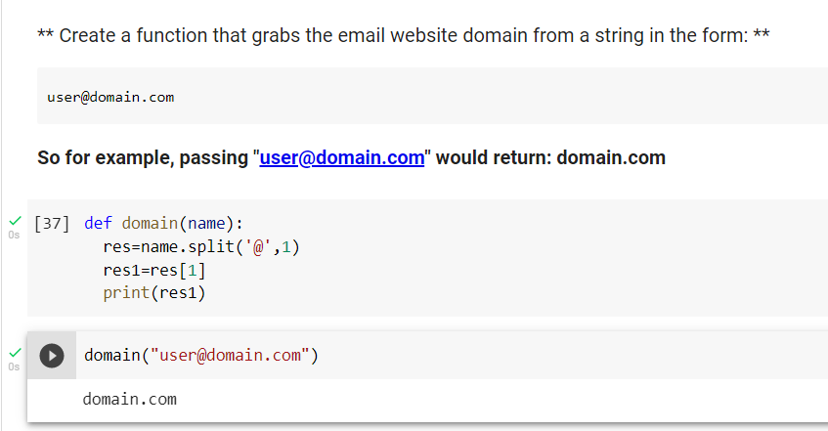

**Expected Output :**

'domain.com'

**Question-8:**

Create a basic function that returns True if the word 'dog' is contained in the input string. Don't worry about edge cases like a punctuation being attached to the word dog, but do account for capitalization.

**Solution :**

    def check(str):

  str1="dog"

  str2=str.lower()

  if str1 in str2:

    print("True")

  else:

    print("False")

check("There is a dog.")

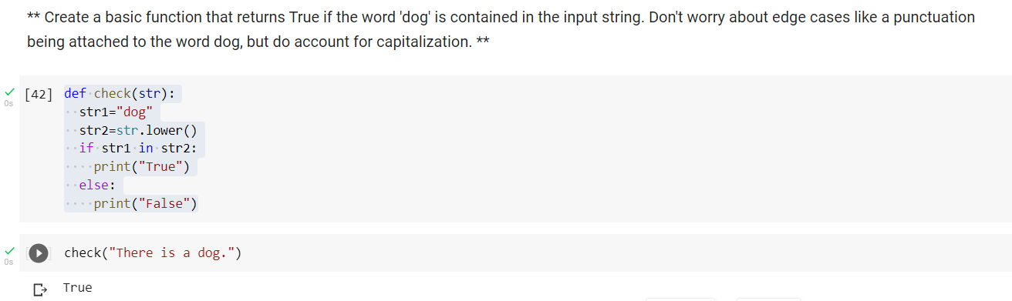

**Expected Output :**

True

**Question-9 :**

Create a function that counts the number of times the word "dog" occurs in a string. Again ignore edge cases.

**Solution :**

def countdog(s):

  count=0

  for s1 in s.lower().split():

    if s1=="dog":

      count=count+1

  return count

countdog("There is a dog and it is a cute DOG")

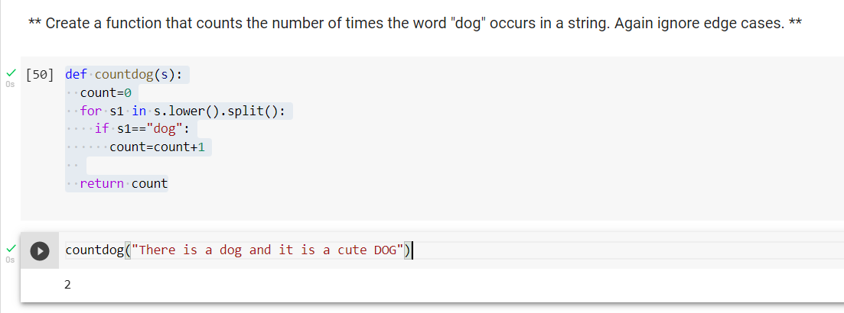

**Expected Output :**

2

**Question-10 :**

**Problem**

You are driving a little too fast, and a police officer stops you. Write a function

to return one of 3 possible results: "No ticket", "Small ticket", or "Big Ticket".

If your speed is 60 or less, the result is "No Ticket". If speed is between 61

and 80 inclusive, the result is "Small Ticket". If speed is 81 or more, the result is "Big Ticket". Unless it is your birthday (encoded as a boolean value in the parameters of the function) -- on your birthday, your speed can be 5 higher in all

cases.

   def caught_speeding(speed, is_birthday):

    if is_birthday:

        speeding = speed - 5

    else:

        speeding = speed

    if speeding > 80:

        return 'Big Ticket'

    elif speeding > 60:

        return 'Small Ticket'

    else:

        return 'No Ticket'

**Solution :**

caught_speeding(90,True)

**Expected Output :**

Big Ticket

**Solution :**

caught_speeding(70,False)

**Expected Output :**

Small Ticket

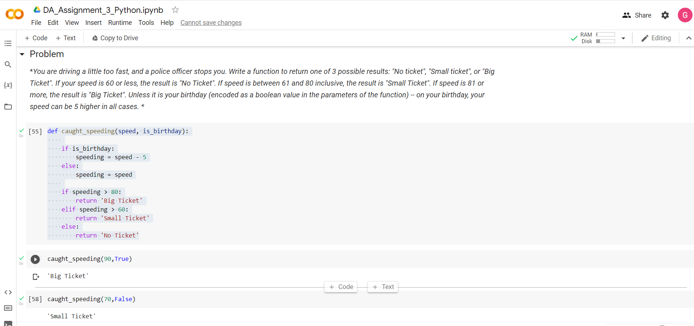

**Question-11:**

Create an employee list with basic salary values(at least 5 values for 5 employees) and using a for loop retreive each employee salary and calculate total salary expenditure.

**Solution :**

employee=["Jose ","John ","Jane ","Jael ","Joel "]

bp=[8000,13500,15000,9000,10500]

total=[]

for i in bp:

    da=0

    hra=0

    cta=0

    gross=0

    da = 20 / 100.0 *i;

    hra = 10 / 100.0 *i;

    cta = 12 / 100.0 * i;

    gross = i + da + hra + cta;

    total.append(gross)

res = "\n".join("{} {} {}".format(x, y, z) for x, y, z in zip(employee, bp, total))

print(res)

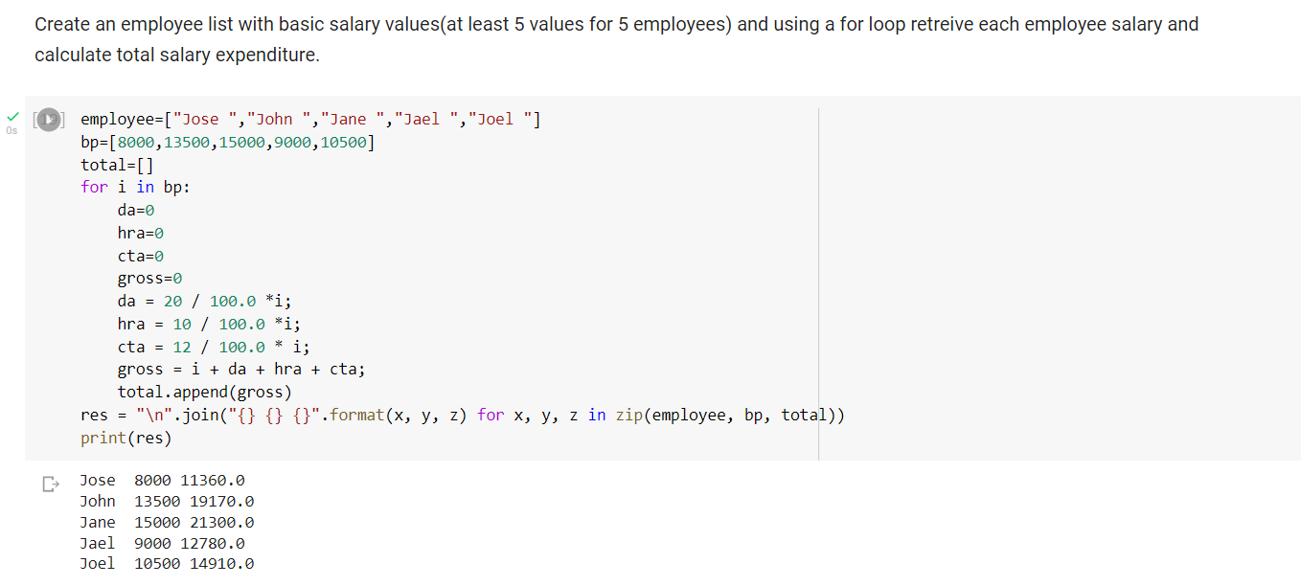

**Question-12 :**

Create two dictionaries in Python: First one to contain fields as Empid, Empname, Basicpay. Second dictionary to contain fields as DeptName, DeptId. Combine both dictionaries.

**Solution :**

def Merge(dict1, dict2):

  return(dict2.update(dict1))

dict1 = {'Empid': 11, 'Empname': "Gifty Sharon",'Basicpay':25000}

dict2 = {'DeptName': "HR", 'DeptId': 101}

print(Merge(dict1, dict2))

print(dict2)

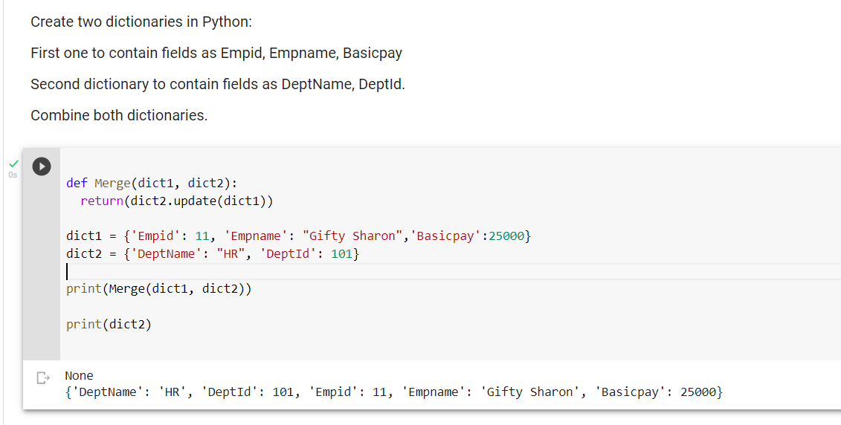

**Colab Link :** <https://colab.research.google.com/drive/1TnapreoQkzbIr4bKXYaBUc80eznW0zJv?usp=sharing>